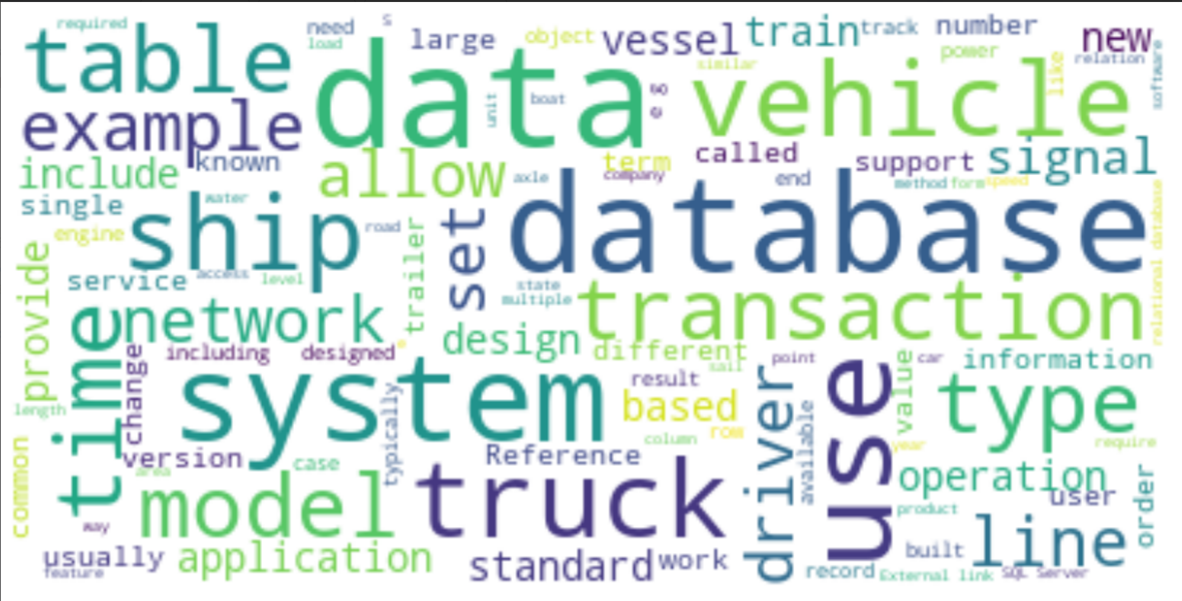

**Caption:** Our Baseline WikiDoMiner WordCloud Results for Domain 1 (Railways) Depicting Most Frequent Words in Corpus of Wikipedia Articles Generated from ERTMS File on train control with Top-K Keyword score of 50 and Wikipedia Depth Search of 1 (direct matching articles + direct matching category articles). Results for Research Question 1.1 with original pre-processing techniques and Jaccard Similarity for Wikipedia Search, replicating original WikiDoMiner tool and study completely.

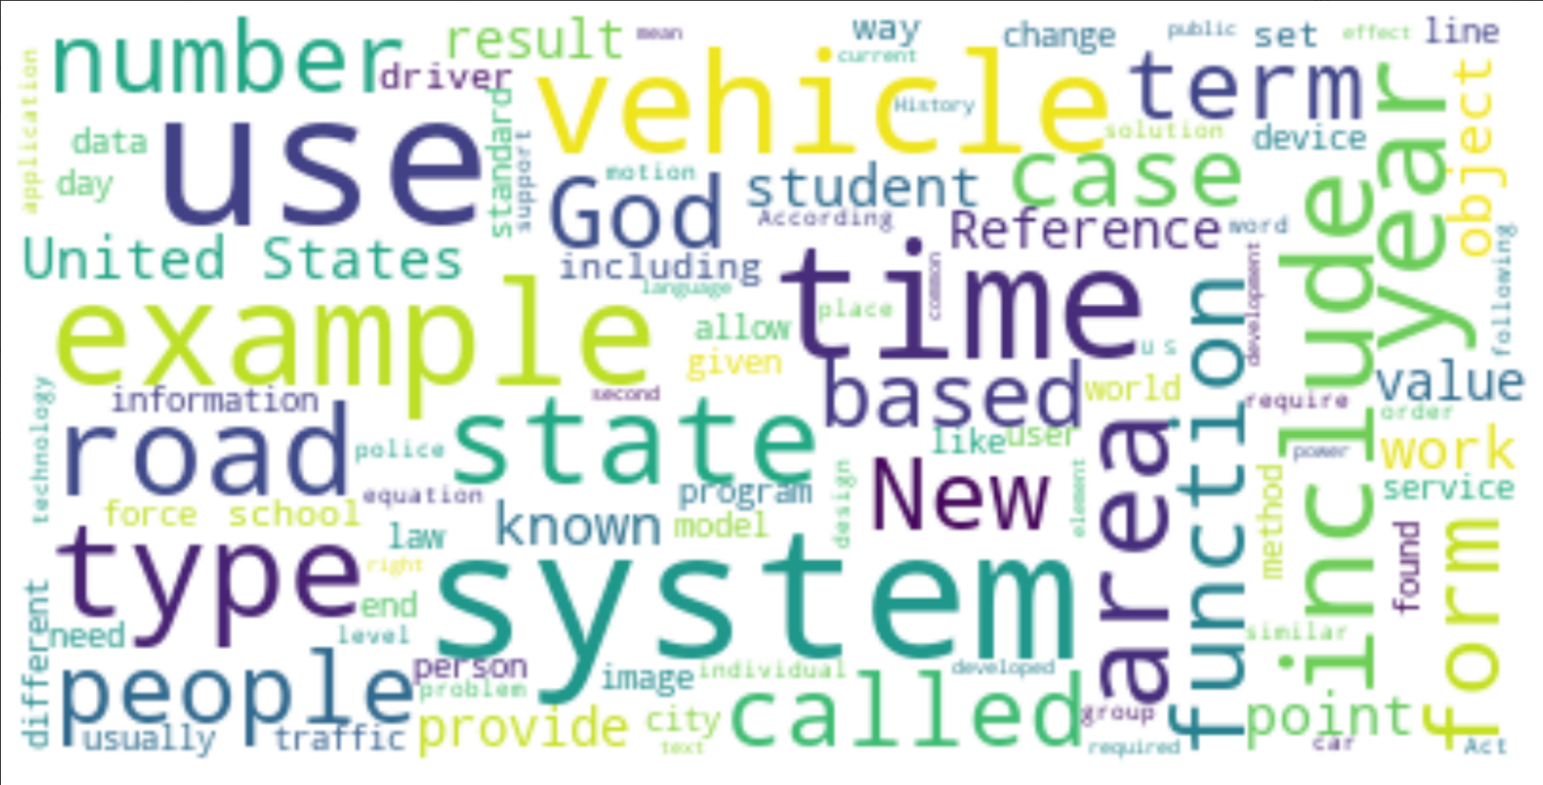

**Caption:** Our Baseline WikiDoMiner WordCloud Results for Domain 2 (Transportation) Depicting Most Frequent Words in Corpus of Wikipedia Articles Generated from CTC-Network File on transportation communication networks with Top-K Keyword score of 50 and Wikipedia Depth Search of 1. Results for Research Question 1.1 with original pre-processing techniques and Jaccard Similarity for Wikipedia Search, replicating original WikiDoMiner tool and study completely.

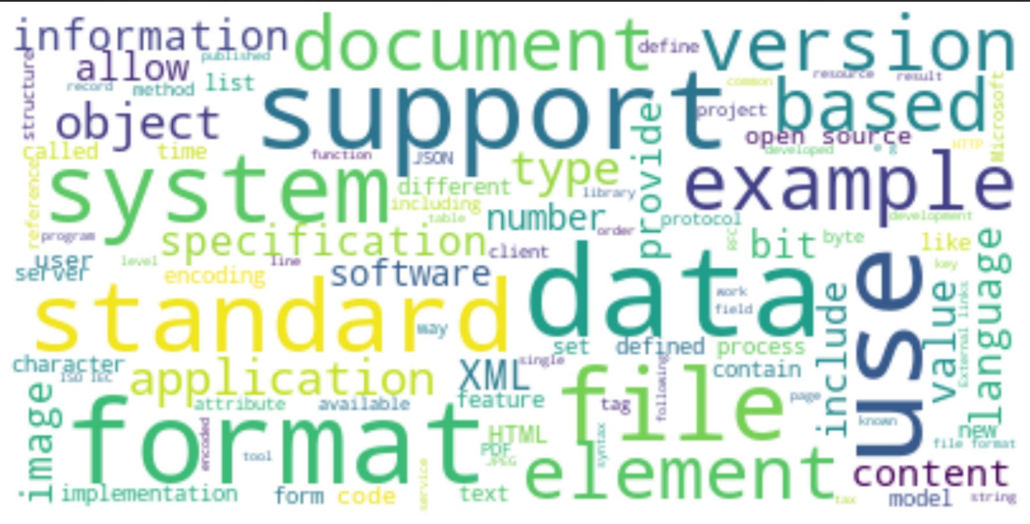

**Caption:** Our Baseline WikiDoMiner WordCloud Results for Domain 3 (Space) Depicting Most Frequent Words in Corpus of Wikipedia Articles Generated from ESA File on space data management with Top-K Keyword score of 50 and Wikipedia Depth Search of 1. Extra results not used for Research Questions, but for pedagogical purposes with same methodology as Research Question 1.1 but on new domains.

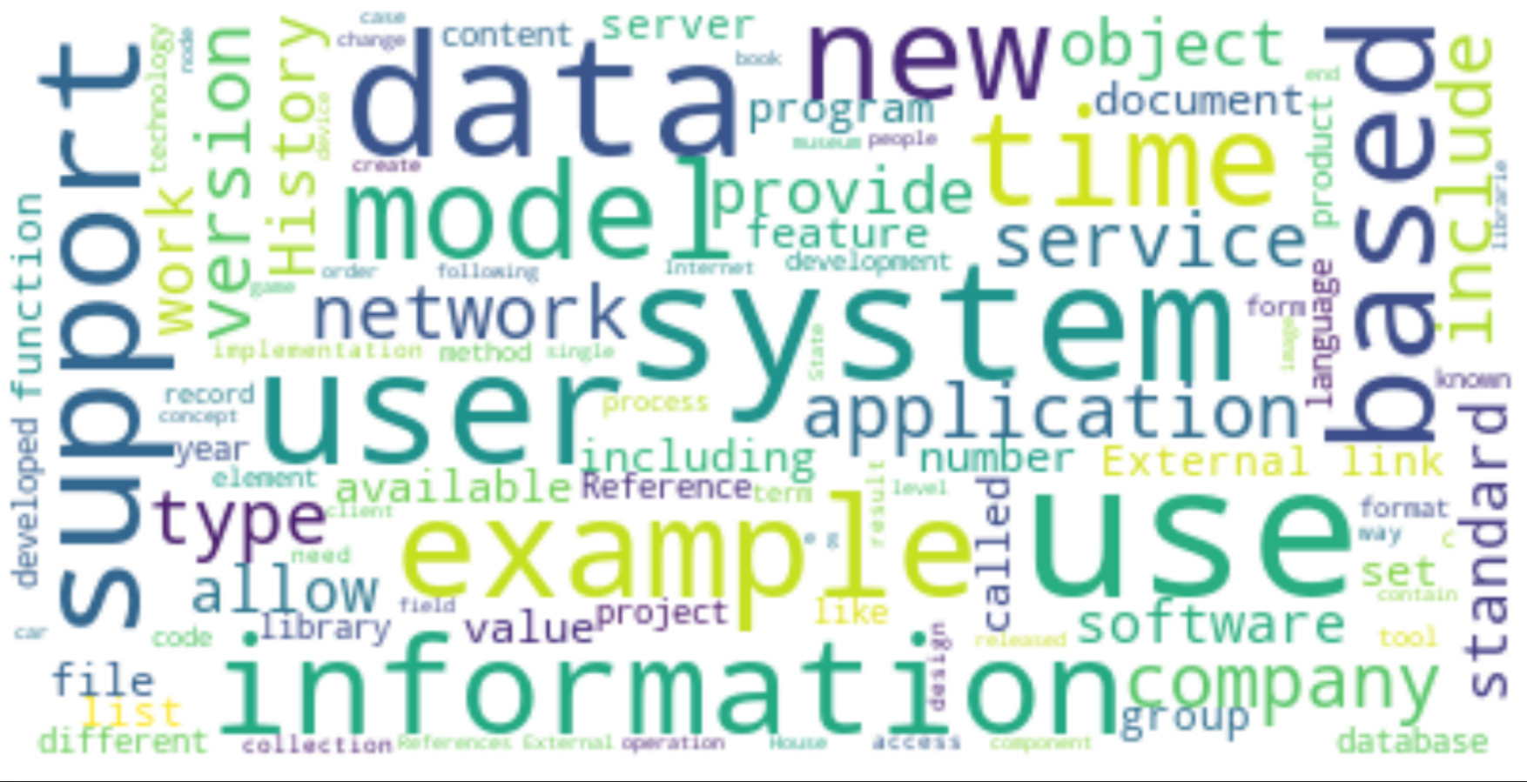

**Caption:** Our Baseline WikiDoMiner WordCloud Results for Domain 4 (Library) Depicting Most Frequent Words in Corpus of Wikipedia Articles Generated from NLM File on National Library of Medicine with Top-K Keyword score of 50 and Wikipedia Depth Search of 1. Extra results not used for Research Questions, but for pedagogical purposes with same methodology as Research Question 1.1 but on new domains.

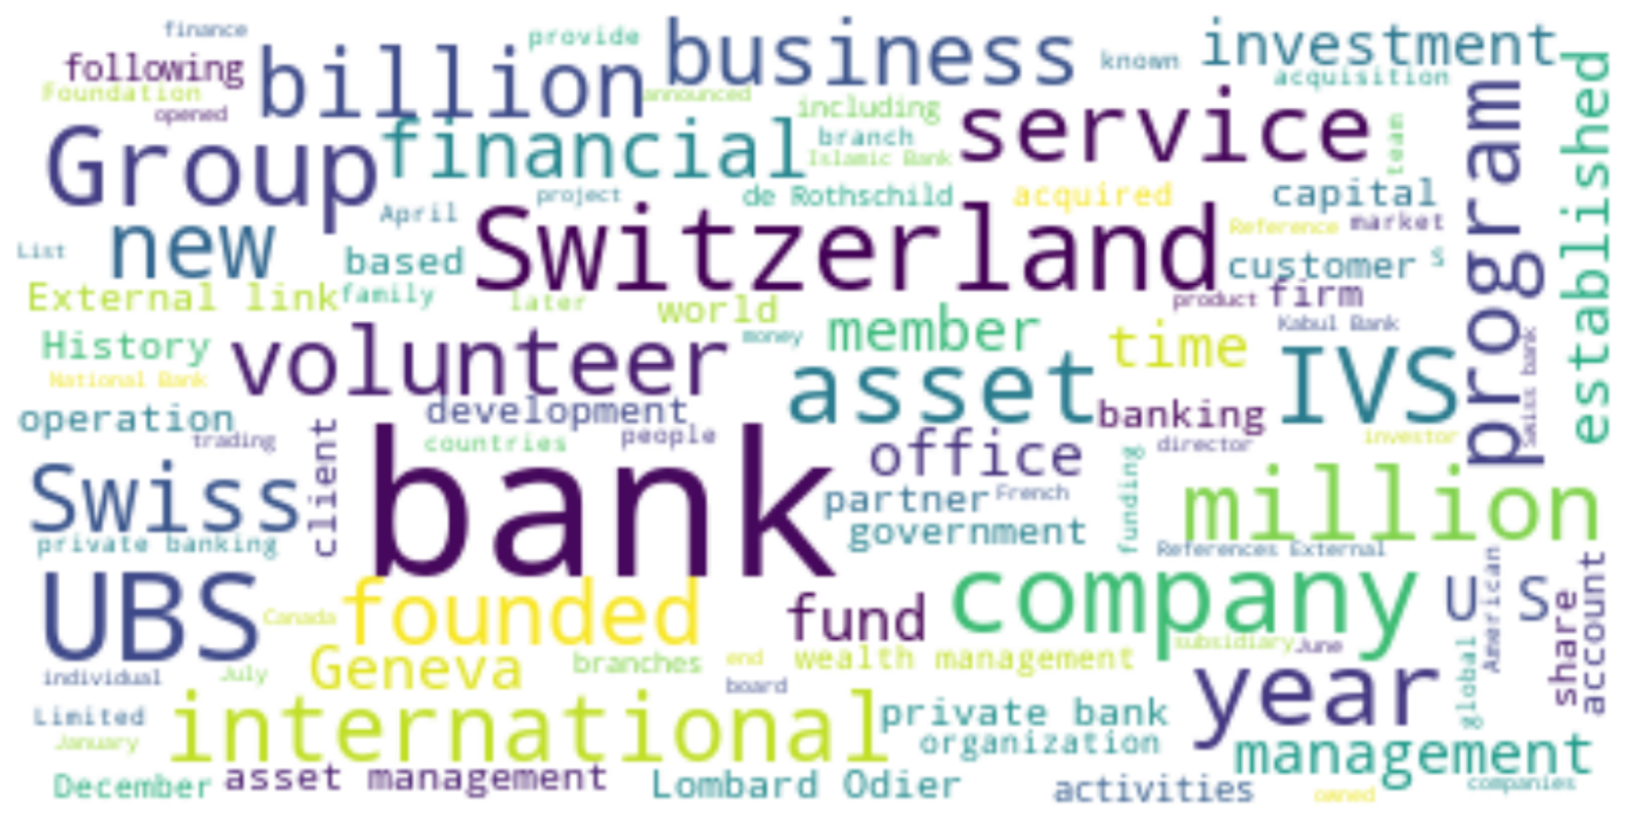

**Caption:** Our Enhanced WikiDoMiner (WDM_En) WordCloud Results for Domain 1 (Railways) Depicting Most Frequent Words in Corpus of Wikipedia Articles Generated from ERTMS File with Top-K Keyword score of 50 and Wikipedia Depth Search of 1. Results for Research Question 1.2 with n-gram tokenization instead of regular tokenization and Cosine Similarity for Wikipedia Search, optimizing the methodology of Original WikiDoMiner tool.

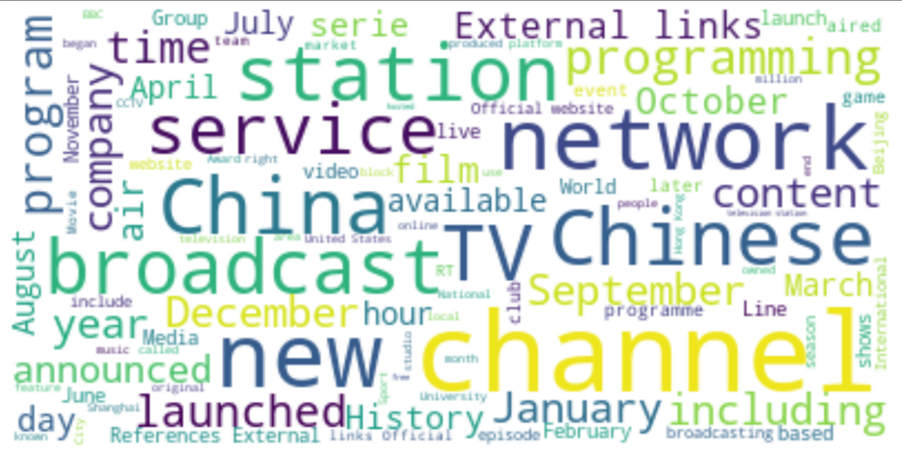**Caption:** Our Enhanced WikiDoMiner (WDM_En) WordCloud Results for Domain 2 (Transportation) Depicting Most Frequent Words in Corpus of Wikipedia Articles Generated from CTC-Network File, with Top-K Keyword score of 50 and Wikipedia Depth Search of 1. Results for Research Question 1.2 with n-gram tokenization instead of regular tokenization and Cosine Similarity for Wikipedia Search, optimizing the methodology of Original WikiDoMiner tool.

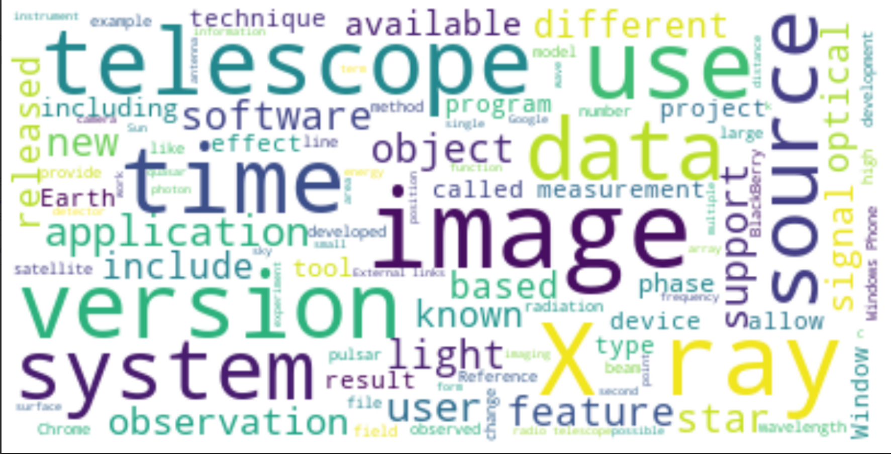**Caption:** Our Enhanced WikiDoMiner (WDM_En) WordCloud Results for Domain 3 (Space) Depicting Most Frequent Words in Corpus of Wikipedia Articles Generated from ESA File, with Top-K Keyword score of 50 and Wikipedia Depth Search of 1. Results for Research Question 1.2 with n-gram tokenization instead of regular tokenization and Cosine Similarity for Wikipedia Search, optimizing the methodology of Original WikiDoMiner tool and with new domain.

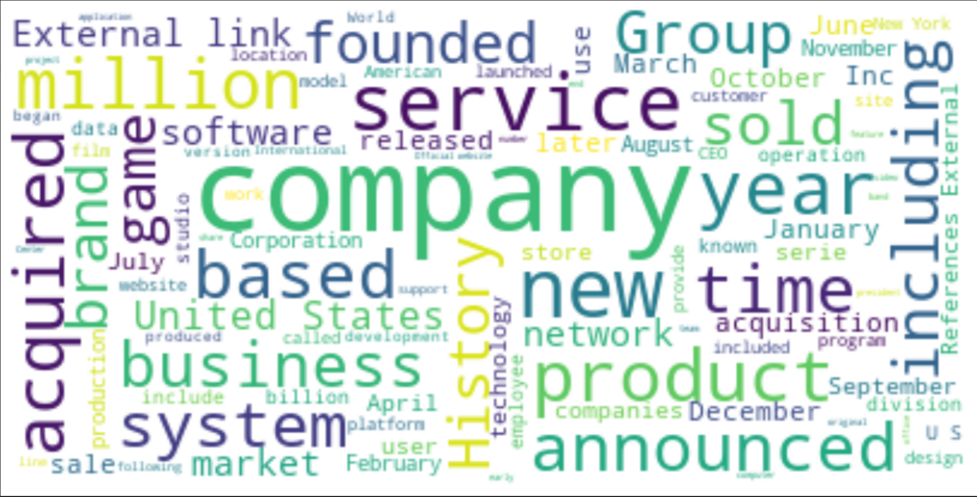**Caption:** Our Enhanced WikiDoMiner (WDM_En) WordCloud Results for Domain 4 (Library) Depicting Most Frequent Words in Corpus of Wikipedia Articles Generated from NLM File, with Top-K Keyword score of 50 and Wikipedia Depth Search of 1. Results for Research Question 1.2 with n-gram tokenization instead of regular tokenization and Cosine Similarity for Wikipedia Search, optimizing the methodology of Original WikiDoMiner tool and with new domain.

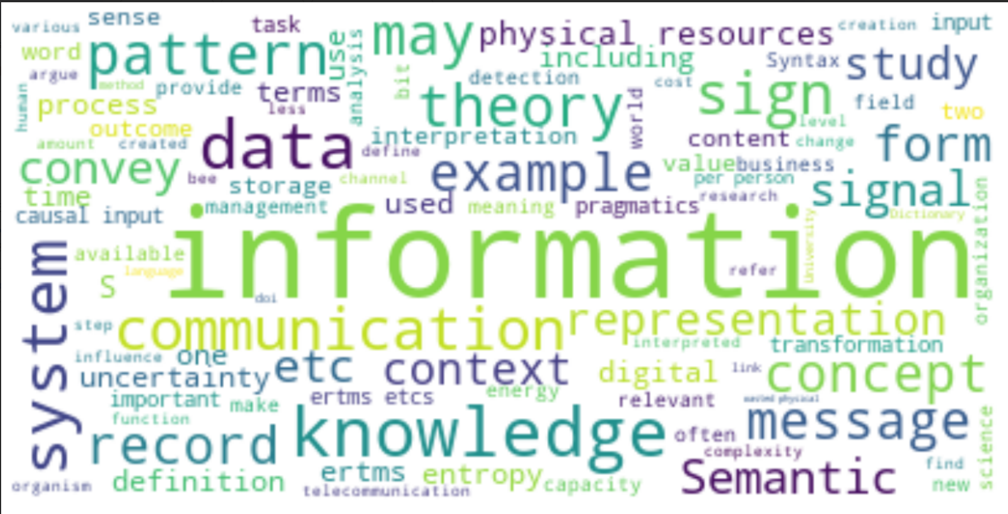**Caption:** Our Bert WikiDoMiner (WDM_BERT) WordCloud Results for Domain 1 (Railways) Depicting Most Frequent Words in Corpus of Wikipedia Articles Generated from ERTMS File, with Top-K Keyphrases score of 25 (with 25 * 2 Keywords) and Wikipedia Depth Search of 1. Results for Research Question 2.2 with only stopword removal pre-processing, BERT Embeddings for keyword extraction, and Jaccard Similarity for Wikipedia searching, with a completely new implementation of Original WikiDoMiner tool.

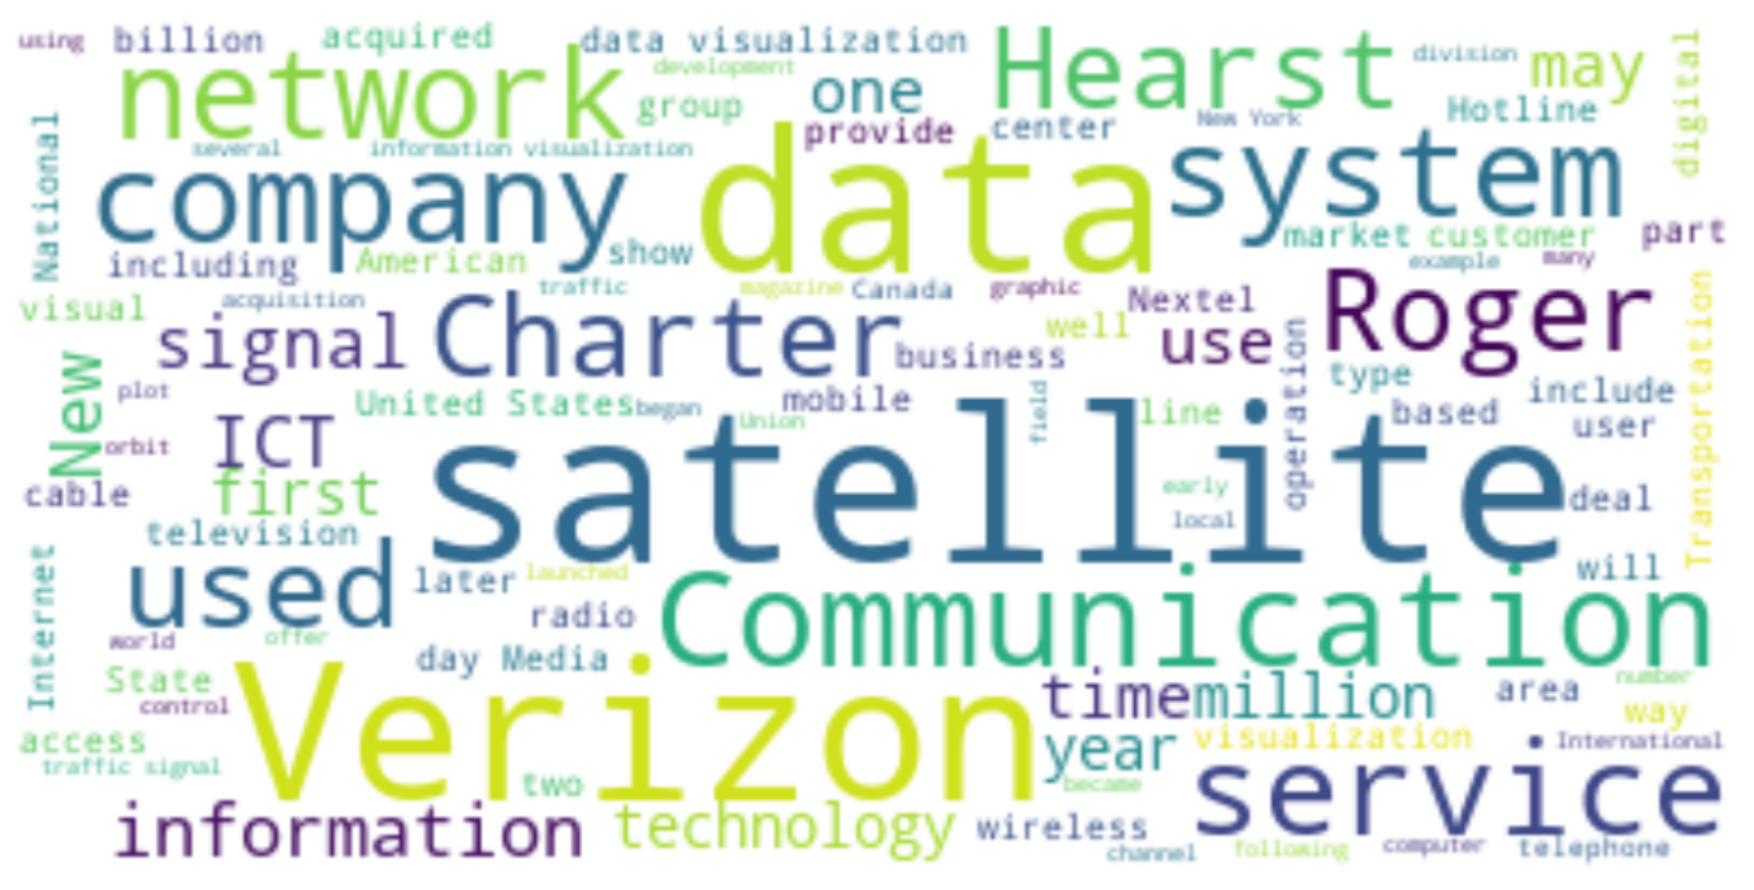**Caption:** Our WikiDoMiner Implementation Using Bert Embeddings for Keyword Extraction (WDM_BERT) WordCloud Results for Domain 2 (Transportation) Depicting Most Frequent Words in Corpus of Wikipedia Articles Generated from CTC-Network File, with Top-K Keyphrases score of 25 (with 25 * 2 Keywords) and Wikipedia Depth Search of 1. Results for Research Question 2.2. Note that while this is not as representative of transportation domain, the terms fit with overall topical nature of inputted RS Document which discusses communication networks.

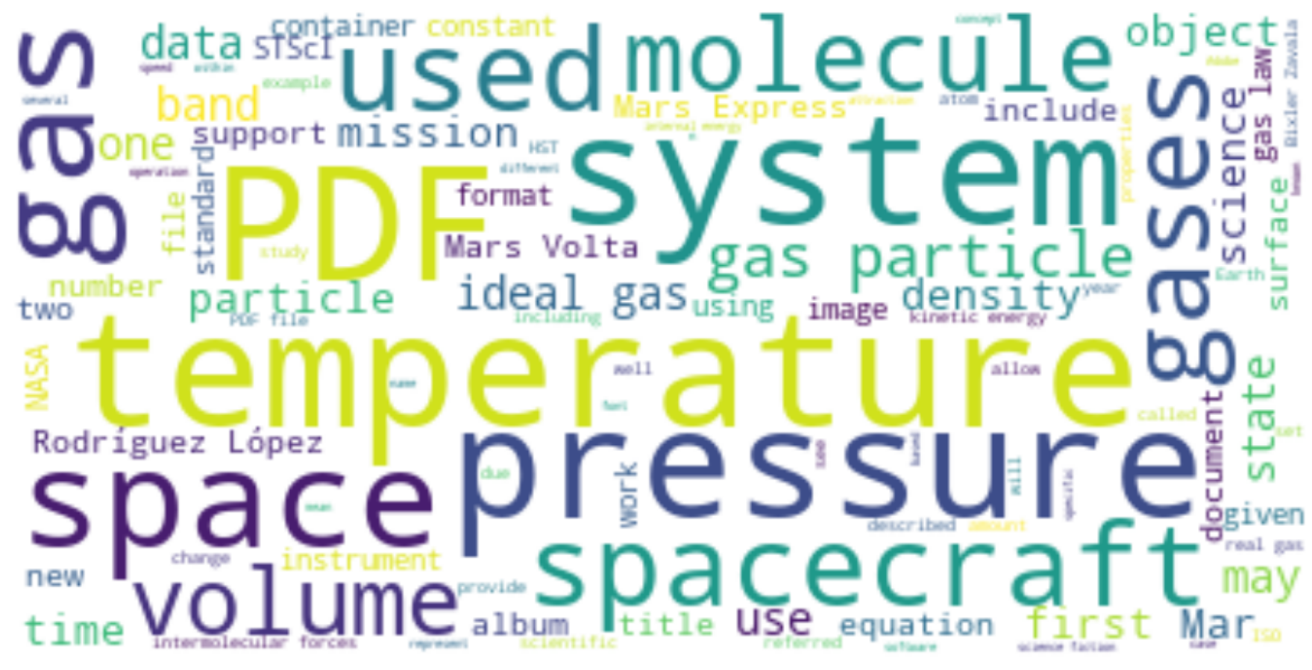**Caption:** Our WikiDoMiner Implementation Using Bert Embeddings for Keyword Extraction (WDM_BERT) WordCloud Results for Domain 3 (Space) Depicting Most Frequent Words in Corpus of Wikipedia Articles Generated from ESA File, with Top-K Keyphrases score of 25 (with 25 * 2 Keywords) and Wikipedia Depth Search of 1. Results for Research Question 2.2.

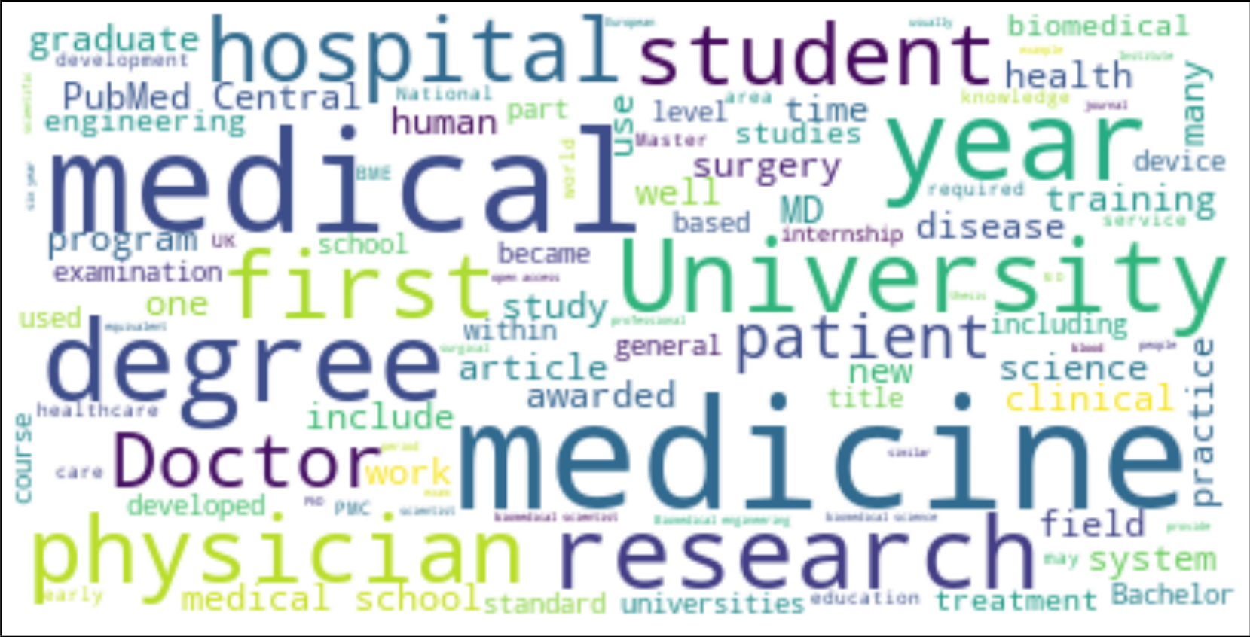

**Caption:** Our WikiDoMiner Implementation Using Bert Embeddings for Keyword Extraction (WDM_BERT) WordCloud Results for Domain 4 (Library) Depicting Most Frequent Words in Corpus of Wikipedia Articles Generated from NLM File, with Top-K Keyphrases score of 25 (with 25 * 2 Keywords) and Wikipedia Depth Search of 1. Results for Research Question 2.2. Note that while this is not as representative of library domain, the terms highly fit with overall topical nature of inputted RS Document which discusses a medical library.

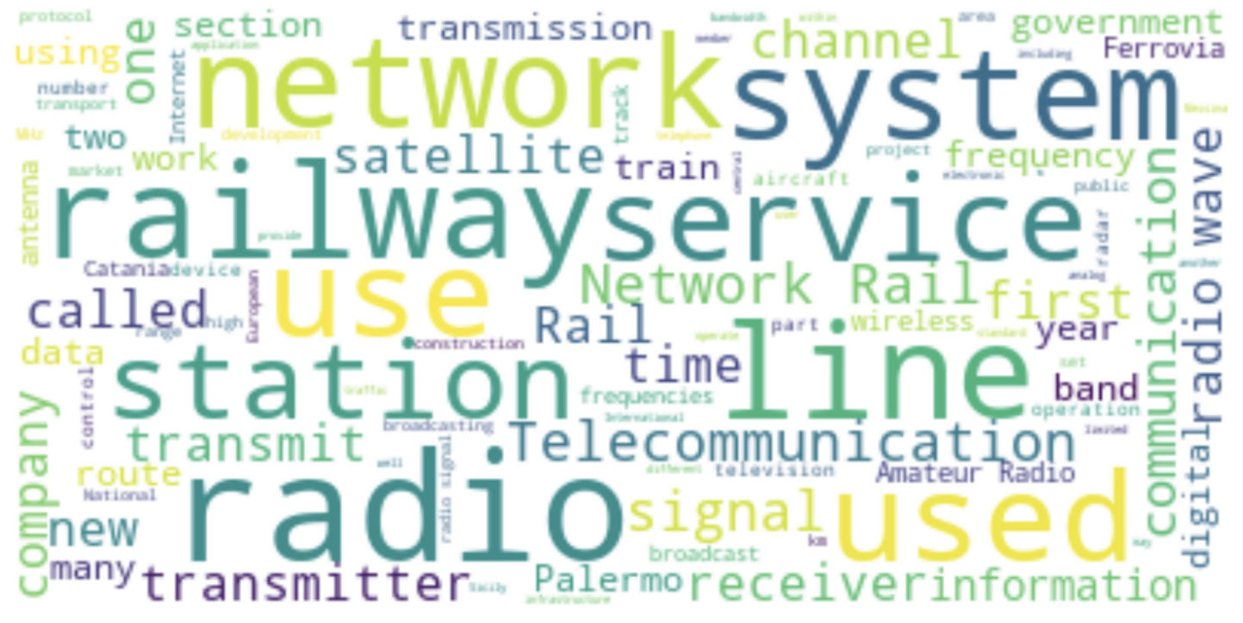**Caption:** Our WikiDoMiner Implementation Using Bert Embeddings for Keyword Extraction (WDM_BERT) WordCloud Results for the EIRENE SYS 15 File on digital radio standard for trains (RS 2) in the Railway Domain. Results not used for any research questions but for pedagogy purposes using WDM_BERT, showing better domain representativeness of railways than ERTMS (RS 1), but was not used due to use of this file for RQ 1.1 which replicated original study and used RS 1.

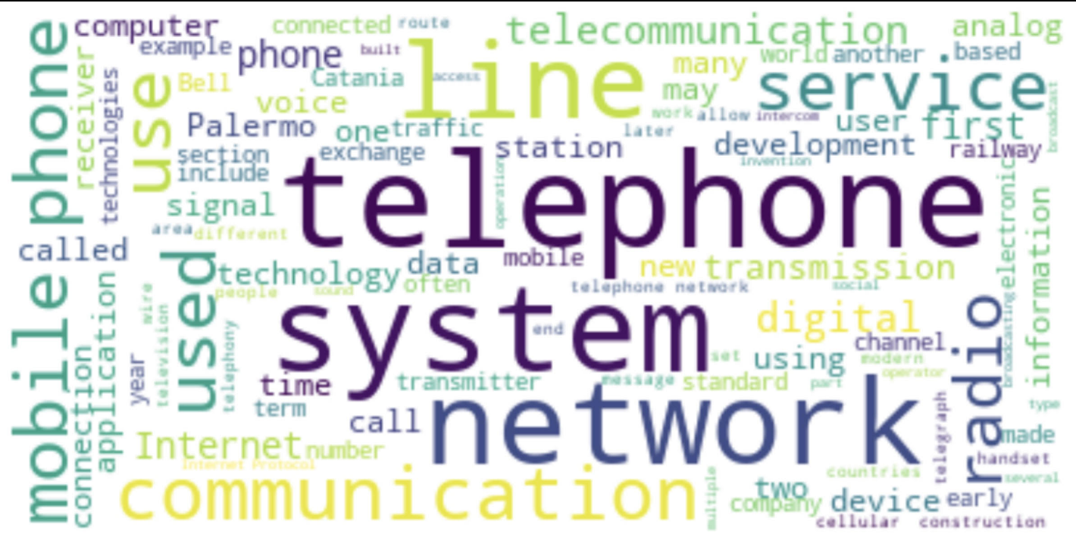**Caption:** Our WikiDoMiner Implementation Using Bert Embeddings for Keyword Extraction (WDM_BERT) WordCloud Results for the EIRENE FUN 7 File on digital radio standard for railways (RS 3) in the Railway Domain. Results not used for any research questions but for pedagogy purposes using WDM_BERT, showing better domain representativeness of railways than ERTMS (RS 1), but was not used due to use of this file for RQ 1.1 which replicated original study and used RS 1.

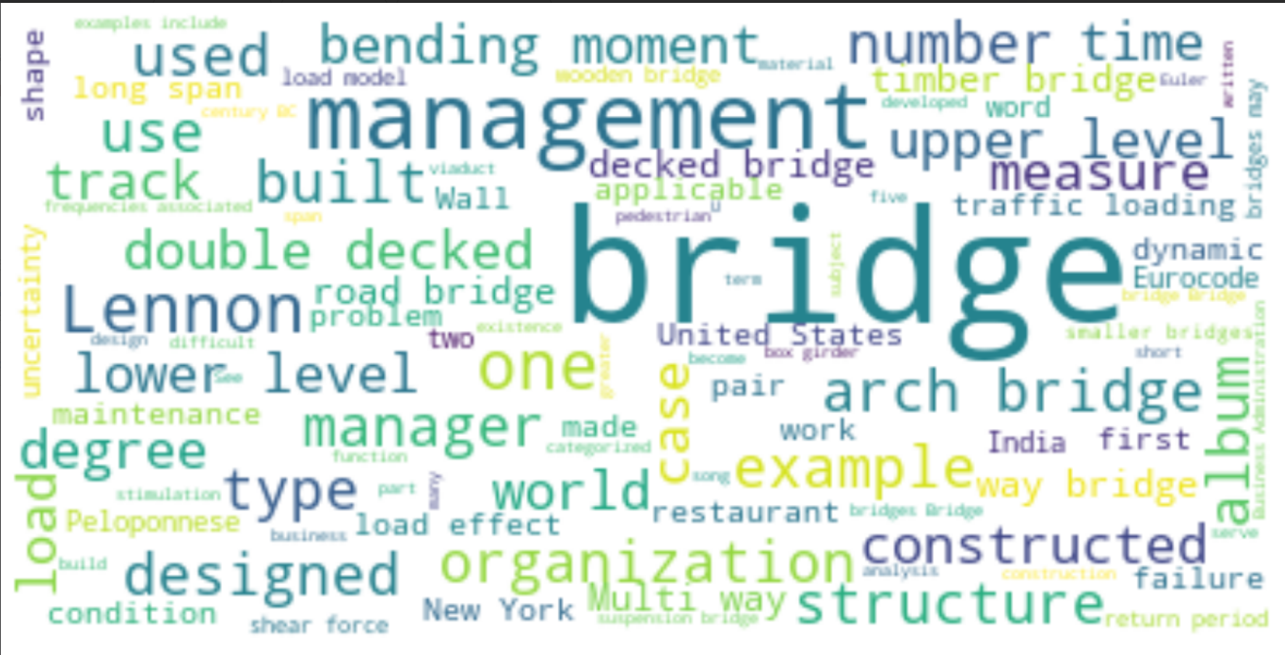**Caption:** Our WikiDoMiner Implementation Using Bert Embeddings for Keyword Extraction (WDM_BERT) WordCloud Results for the PONTIS File on highway management (RS 5) in the Transportation Domain. Results not used for any research questions but for pedagogy purposes using WDM_BERT, showing slight better domain representativeness of transportation than CTC Network (RS 4), but was not used due to use of this file for RQ 1.1 which replicated original study and used RS 4.

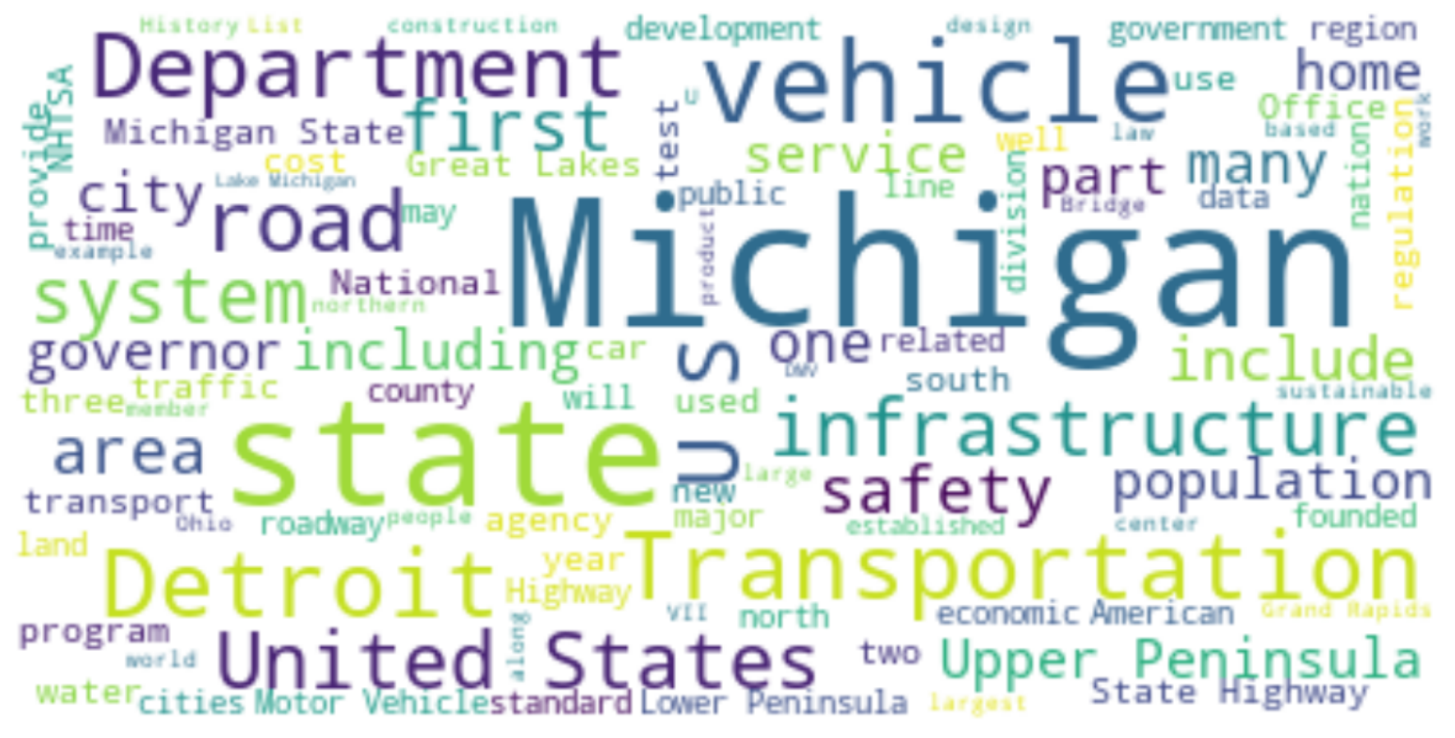**Caption:** Our WikiDoMiner Implementation Using Bert Embeddings for Keyword Extraction (WDM_BERT) WordCloud Results for the MDOT File on transportation management (RS 6) in the Transportation Domain. Results not used for any research questions but for pedagogy purposes using WDM_BERT, showing slight better domain representativeness of transportation than CTC Network (RS 4), but was not used due to use of this file for RQ 1.1 which replicated original study and used RS 4.

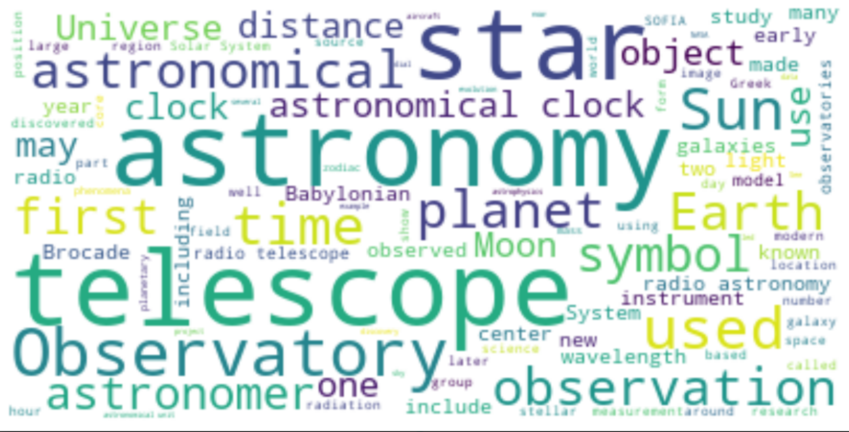**Caption:** Our WikiDoMiner Implementation Using Bert Embeddings for Keyword Extraction (WDM_BERT) WordCloud Results for the EVLA BACK File on astronomy data management (RS 8) in the Space Domain. Results not used for any research questions but for pedagogy purposes using WDM_BERT.

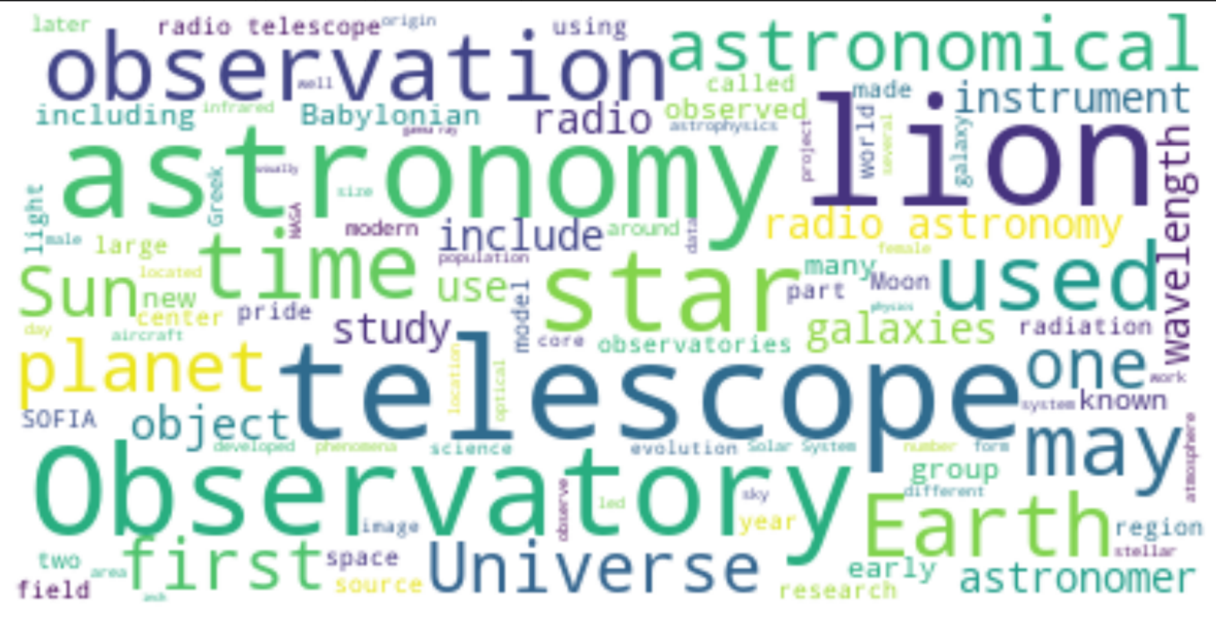**Caption:** Our WikiDoMiner Implementation Using Bert Embeddings for Keyword Extraction (WDM_BERT) WordCloud Results for the EVLA CORR File on astronomy data management (RS 9) in the Space Domain. Results not used for any research questions but for pedagogy purposes using WDM_BERT.

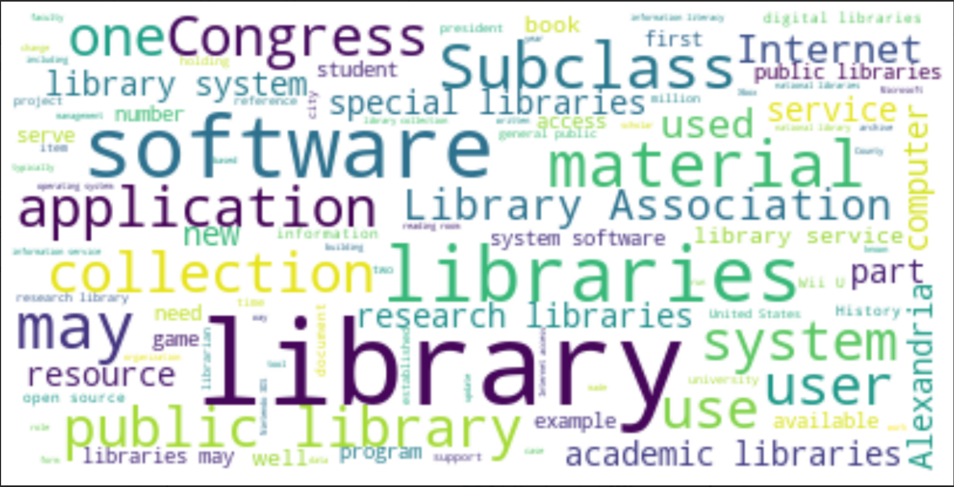**Caption:** Our WikiDoMiner Implementation Using Bert Embeddings for Keyword Extraction (WDM_BERT) WordCloud Results for the Library File on a library technology system (RS 11) in the Library Domain. Results not used for any research questions but for pedagogy purposes using WDM_BERT.

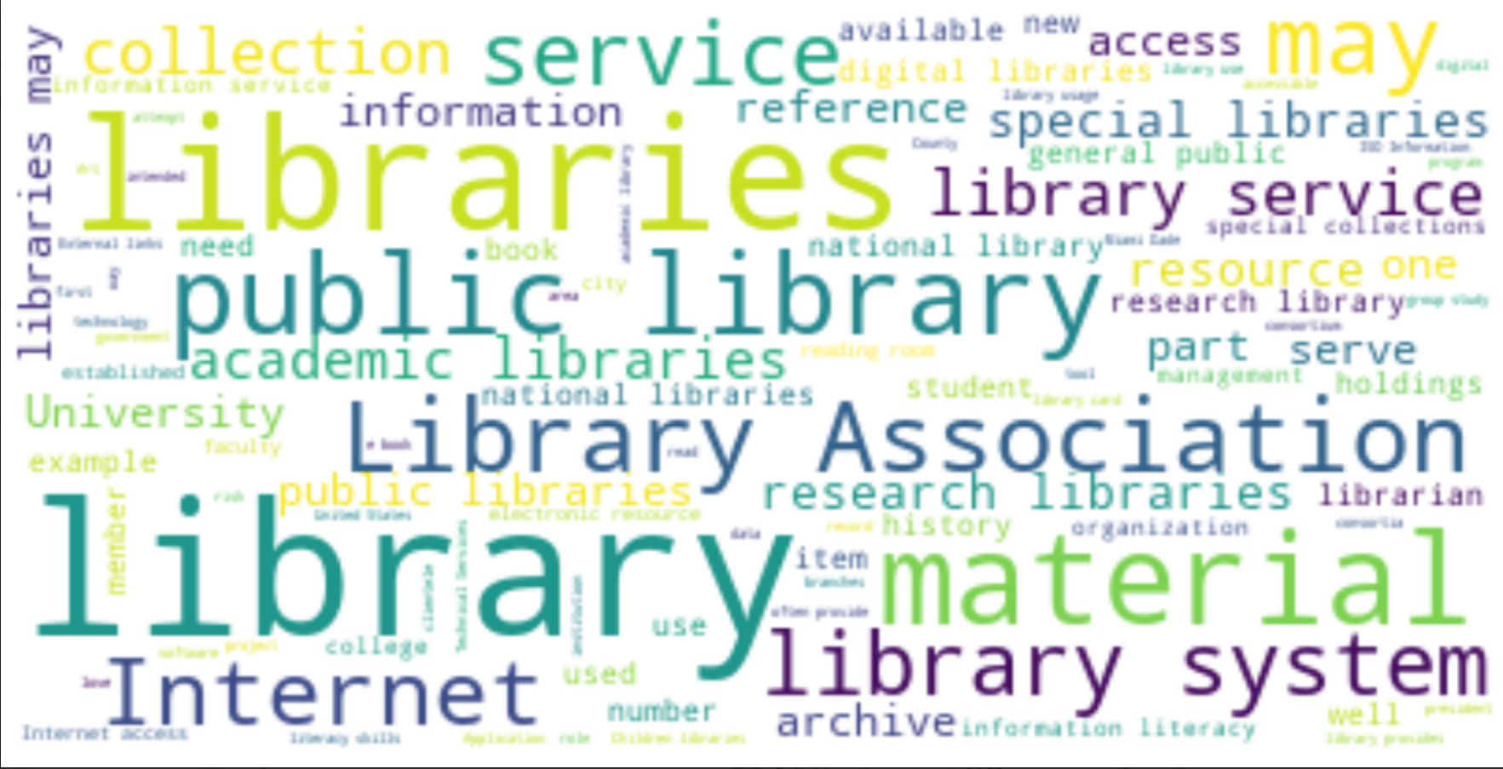**Caption:** Our WikiDoMiner Implementation Using Bert Embeddings for Keyword Extraction (WDM_BERT) WordCloud Results for the Library File on a library database management system (RS 12) in the Library Domain. Results not used for any research questions but for pedagogy purposes using WDM_BERT.